**Problem 1 (5 points):**

**Solve the recurrence $T\left(n\right)=2T\left(\frac{2}{3} n\right)+n^{2}$  first by using a recursion tree and then using the Master theorem. Show work.**

Recursion Tree:

First, we calculate cost at each level:

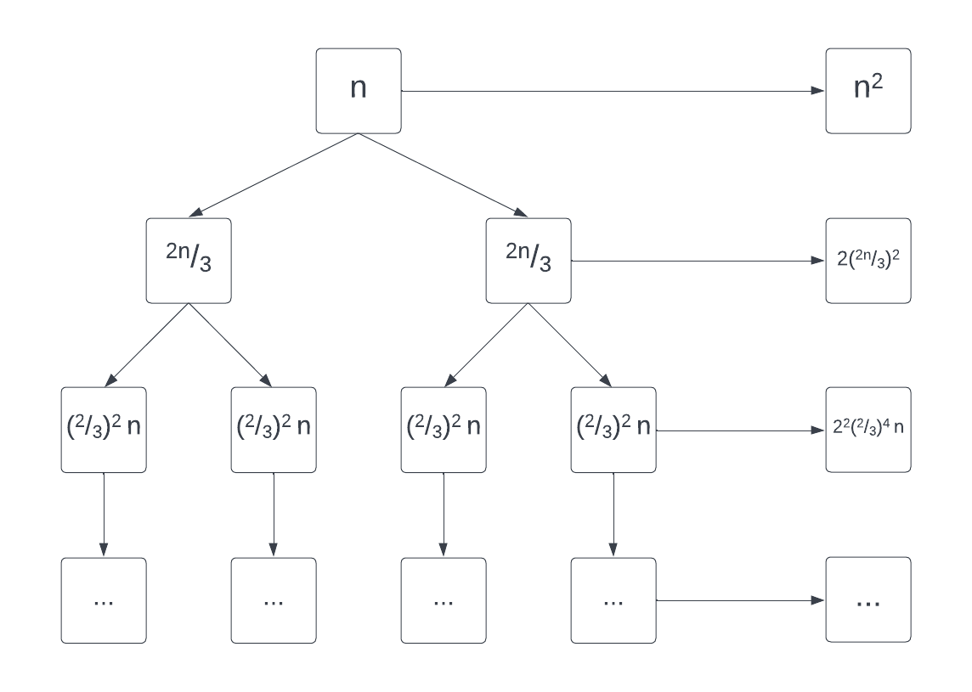

$$\frac{2n}{3}+\frac{2n}{3} → {\left(\frac{2}{3}\right)}^{2}n^{2}+{\left(\frac{2}{3}\right)}^{2}n^{2}→ 2{\left(\frac{2}{3}n\right)}^{2}$$

$${\left(\frac{2}{3}\right)}^{2}n^{2}+ {\left(\frac{2}{3}\right)}^{2}n+…→2^{2}{\left(\frac{2}{3}\right)}^{4}n^{2}$$

Assuming k levels, at the kth level we see:

$${\left(\frac{2}{3}\right)}^{k}n=1, and so k= \log_{2/3}n levels$$

Finally, identify asymptotic bound:

$$T\left(n\right)= n^{2}\left[ 2^{0}*{\left(\frac{2}{3}\right)}^{0}+2^{1}*{\left(\frac{2}{3}\right)}^{1}+2^{2}*{\left(\frac{2}{3}\right)}^{2}+…to k\right]$$

$$T\left(n\right)= n^{2}\left[ {\left(\frac{8}{9}\right)}^{0}+{\left(\frac{8}{9}\right)}^{1}+{\left(\frac{8}{9}\right)}^{2}+…to k\right]$$

$$T\left(n\right)=n^{2}\left[\frac{ 1*\left(1-{\left(\frac{8}{9}\right)}^{\log_{\frac{3}{2}}n+1}\right)}{1-\frac{8}{9}}\right]=n^{2}\left[ 1-\frac{8}{9}*n^{\log_{\frac{3}{2}}\left(\frac{8}{9}\right) }\right]$$

$$∴As n^{\log_{\frac{3}{2}}\left(\frac{8}{9}\right)}→0, We see that T\left(n\right)= θ\left(n^{2}\right)$$

Master Theorem:

$$T\left(n\right)=aT\left(\frac{n}{b}\right)+f\left(n\right)$$

$$…where f\left(n\right)is of the form n^{c} in which c≥0$$

$$T\left(n\right)∈ \left\{\begin{matrix}if f\left(n\right)=O(n^{\log_{b}a-ε}) & T\left(n\right)=O(n^{\log_{b}a}) & Case 1 \\ if f\left(n\right)=Ω(n^{\log_{b}a+ε}) & T\left(n\right)=θ(f(n)) & Case 2 \\ if f\left(n\right)=θ\left(n^{\log_{b}a}*{\left(logn\right)}^{k}\right) & T\left(n\right)=θ\left(n^{\log_{b}a}*{\left(\log{n}\right)}^{k+1}\right) & Case 3\end{matrix}\right\}$$

$$First, we can rearrange:$$

$$T\left(n\right)=2T\left(\frac{2}{3} n\right)+n^{2}$$

$$We see that f\left(n\right)=n^{2}, and n^{\log_{b}a}=n^{\log_{3/2}2}$$

$$f\left(n\right)= Ω(n^{\log_{b}a+ε})$$

$$when f\left(n\right)≥ n^{\log_{\frac{3}{2}}2},$$

$$∴Therefore T\left(n\right)= θ(n^{2})$$

**Problem 2 (5 points):**

**Give asymptotic upper and lower bounds for the recurrence $T\left(n\right)=3T\left(\frac{n}{2}\right)+ \frac{n}{log n}$. Justify your answer.**

$$Using the Master Theorem:$$

$$T\left(n\right)=aT\left(\frac{n}{b}\right)+f\left(n\right), where a≥1, b≥1, f is asymptotically positive$$

$$a=3, b=2, d=1$$

$$Case \#1: d>\log_{b}a$$

$$f\left(n\right)= θ\left(n^{d}\right) when d> \log_{b}a$$

$$T\left(n\right) ϵ θ(f\left(n\right))$$

$$Case \#2: d=\log_{b}a$$

$$f\left(n\right)= θ\left(n^{d}\log{n}\right) when d= \log_{b}a$$

$$Therefore, T\left(n\right) ϵ θ(n^{d}\log{n})$$

$$Case \#3: d<\log_{b}a$$

$$f\left(n\right)= θ\left(n^{\log_{b}a}\right) when d< \log_{b}a$$

$$T\left(n\right) ϵ θ(n^{\log_{b}a})$$

$$T\left(n\right)=3T\left(\frac{n}{2}\right)+ \frac{n}{logn}$$

$When a=3, b=2, and f\left(n\right)= \frac{n}{\log{n}}$ < n

$$∴We can say that f\left(n\right)= θ\left(n\right), and using case \#1, T\left(n\right) ϵ θ(n^{\log_{2}3})$$

**Problem 3 (10 = 5 + 5 points):**

**Give asymptotic upper and lower bounds for each of the following recurrences. Justify your answer.  
(a) $T\left(n\right)= \sqrt{n}T\left(\sqrt{n}\right)+n$**

$$T\left(n\right)= \sqrt{n}*T\left(\sqrt{n}\right)+n$$

$$T\left(n\right)= n^{\frac{1}{2}}*T\left(n^{\frac{1}{2}}\right)+n$$

$$T\left(n\right)= n^{\frac{1}{2}}*\left(n^{\frac{1}{4}}T\left(n^{\frac{1}{4}}+n^{\frac{1}{2}}\right)\right)+n$$

$$T\left(n\right)= n^{\frac{3}{4}}*T\left(n^{\frac{1}{2}}\right)+2n$$

$$T\left(n\right)= n^{\frac{7}{8}}*T\left(n^{\frac{1}{8}}\right)+3n$$

$$T\left(n\right)= n^{1-{\frac{1}{2}}^{k}}*T\left(n^{{\frac{1}{2}}^{k}}\right)+kn$$

$$In the event that n^{{\frac{1}{2}}^{k}}is less than 2, then k>\log{\log{n}}$$

$$∴Therefore, T\left(n\right)= θ(n\log{\log{n)}}$$

$$Alternatively we can also say that$$

$$S\left(n\right)= \frac{T\left(n\right)}{n}$$

$$In this case, the recurrence now becomes:$$

$$S\left(n\right)=S\left(\sqrt{n}\right)+n$$

$$Via recursion tree, we can see that S\left(n\right)= θ(n\log{\log{n})}$$

$$∴Therefore, T\left(n\right)= θ(n\log{\log{n)}}$$

**(b) $T\left(n\right)=3T(n-1)$**

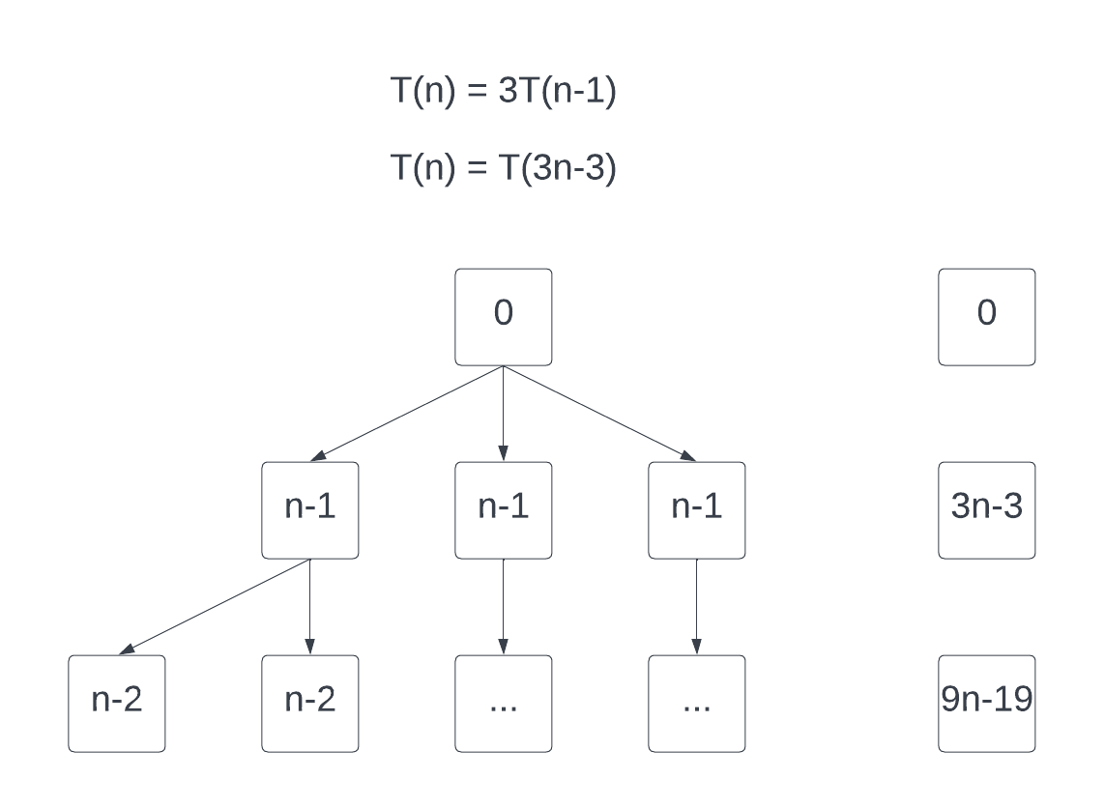 $Via Recursion Tree, we can say that:$

$$T\left(n\right)=3T(n-1)$$

$$T\left(n\right)=3T\left(n-1\right)+0$$

$$T\left(n\right)=T\left(3n-3\right)+0$$

$$=3^{0}n+3^{1}n+3^{2}n+3^{3}n+…$$

$$∴Therefore, T\left(n\right)=θ(3^{n})$$

$$In addition:$$

$$T\left(n\right)=3(3T\left(n-2\right)$$

$$T\left(n\right)=3^{2}T\left(n-2\right)$$

$$T\left(n\right)=3^{2}\left(3T\left(n-3\right)\right)=3^{3}\left(T\left(n-3\right)\right)$$

$$Given a value k, we can say that$$

$$T\left(n\right)=3^{k}\left(T\left(n-k\right)\right)$$

$$T\left(n\right)=3^{n}\left(T\left(0\right)\right)$$

$$∴Therefore, T\left(n\right)= θ(3^{n})$$

**Problem 4: Programming Assignment (10 points):**

* **Maximum Product Subarray**
* **Given an integer array nums, find a contiguous non-empty subarray within the array that has the largest product, and return *the product*.**
* **The test cases are generated so that the answer will fit in a 32-bit integer.**
* **A subarray is a contiguous subsequence of the array.**

Please find a zip file attached with the code provided in the form of a Jupyter notebook. Using **Python3**, you can install Jupyter Notebook via ‘pip install jupyter notebook’. Once installed, you can run the commands you will see below.

The following figure shows the function **maximumSubArrayProductFinder** which takes one argument, an array **nums**. The function will check for an empty or too large of an array, before going through the given array to find the largest product of a sub array.

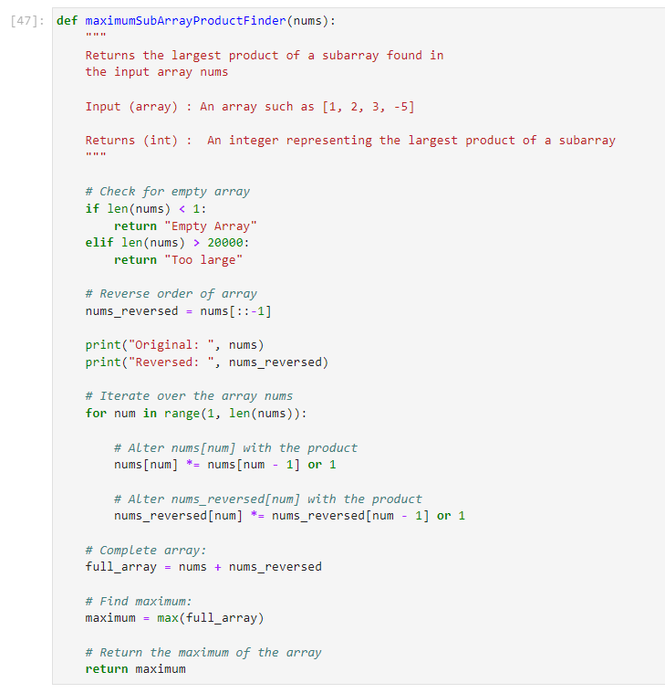

The following figure show 11 test cases developed to demonstrate the both the examples included in the assignments specification, as well as a few others. Each test case has an **input_array_n**, the **function** being executed with that array, as well as the **output**. These test cases show the utility of the application to handle the ability of finding sub array products, as well as ensuring that edge cases are handled properly.

